Neural networks and Deep learning Assignment-5

Name: Venkata Naveen Grandhi_

ID: 7700755549

**GitHub Link:**

<https://github.com/Jhansi-Veluvolu/Neural_Network_Assignment_5>

1. Implement Naïve Bayes method using scikit-learn library Use dataset available with name glass Use train_test_split to create training and testing part Evaluate the model on test part using score and classification_report(y_true, y_pred).

**Output-1:**

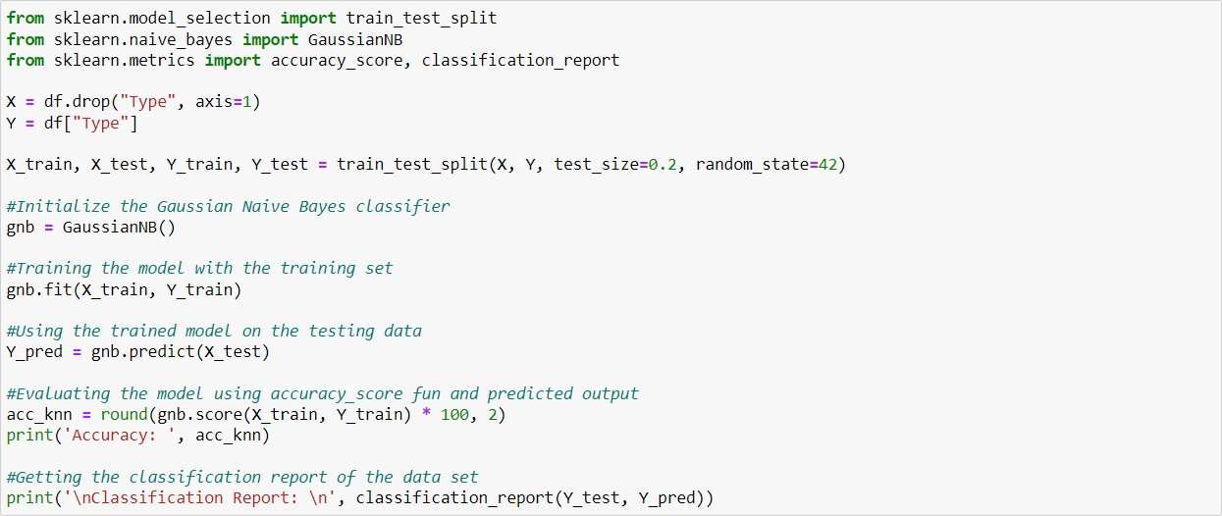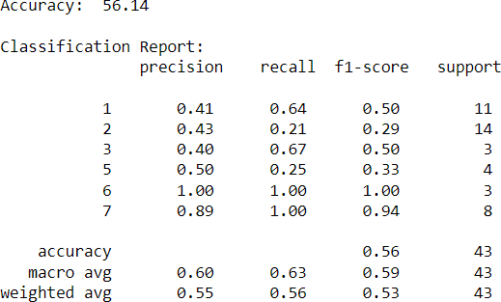

1. Implement linear SVM method using scikit library Use the same dataset above Use

train_test_split to create training and testing part Evaluate the model on test part using score and classification_report(y_true, y_pred) Which algorithm you got better accuracy? Can you justify why?

**Output-2:**

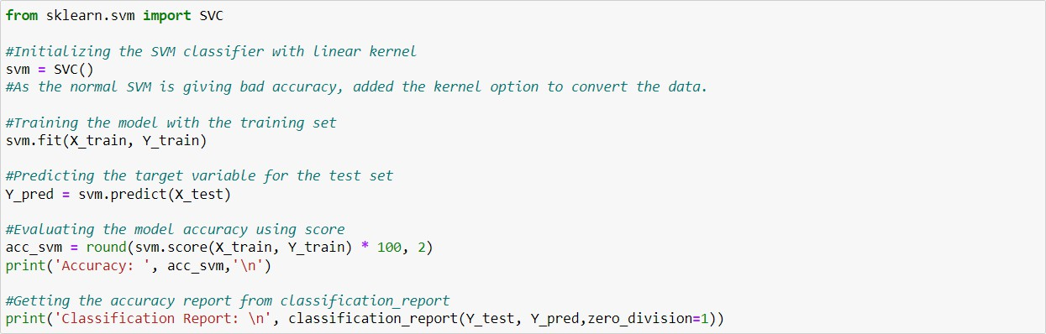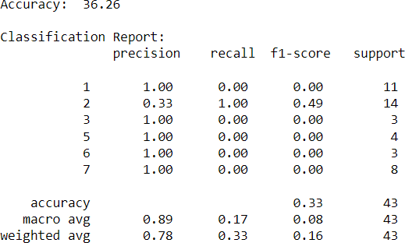

**Data Set**

